**ASSIGNMENT SUBMISSION COVER SHEET**

Cse24-071

**Student Id:**

Atang mokwena

**Student names:**

Cse24-071@thuto.bac.ac.bw

**Student email**:

**Cohort**:

Cse24

OBJECT ORIENTED ANALYSIS & DESIGN WITH JAVA

**Assignment title:**

19/09/2025

**Date of submission**:

Cse

**Programme of**

**Study**:

**Year of Study**:

Year2

**Intellectual property statement**

By checking the box below, I certify that this assignment is my own work and is free from plagiarism. I understand that the assignment may be checked for plagiarism by electronic or other means and may be transferred and stored in a database for the purposes of data-matching to help detect plagiarism. The assignment has not previously been submitted for assessment in any other unit or to any other institution. **I**

**have read and understood the Botswana Accountancy College plagiarism guidelines policy.**

☐ Agree **Signature**……A.Mokwena……………………………….

**Date**…………19/09/2025……………………………….

1. **Requirements Elicitation**

1.1.Functional Requirements:

-The system should be able to add new customers

-Customers must be able to open and manage different types of accounts

-The system should allow deposits, withdrawals, fund transfers, and account balance inquiries.

-Authentication and authorization features to ensure secure access.

-The system should automatically compute and apply interest monthly.

1.2.Non-Functional Requirements

Performance:

-The system must process transactions with minimal delays.

Reliability

-the system must have high uptime and provide backup and recovery mechanisms.

Usability:

-Intuitive interface for registering customers, opening accounts, and performing transactions.

Scalability:

-the system should support future expansion in terms of new services and more users.

Security;

-customer data and transactions must be encrypted and access must be role-based.

1. **Structural UML Modelling**
   1. System Use Case Diagram

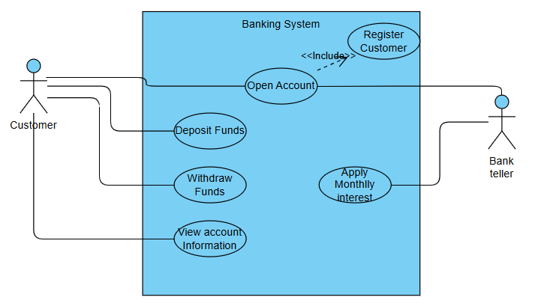

* 1. Class diagram

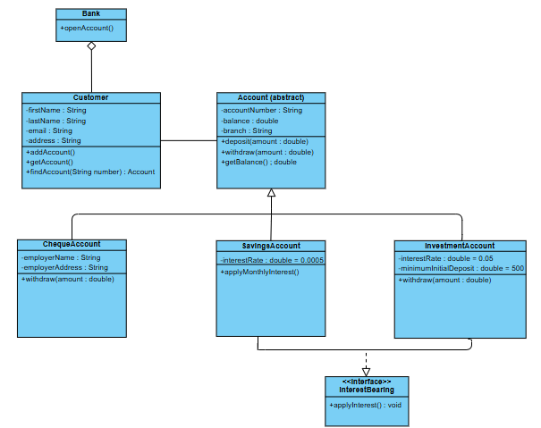

1. **Behavioural UML Modelling**
   1. Sequence Diagram

Login:

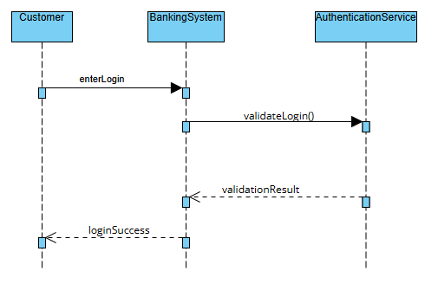

Deposit:

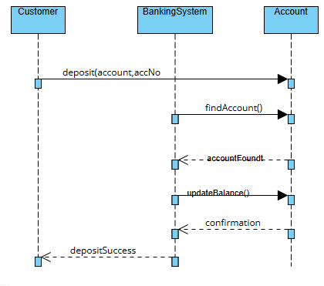

* 1. State Diagram:

